Creating a first microservice using springboot and rest api

Creating a service is a similar to creating any springboot web application it contains a set of rest api services that is consumed by other services or external client. So lets start creating spring boot app using spring.io and necessary dependency as below

Add the following dependency

* Web
* Devtools
* Actuator
* H2 db
* Data jpa
* Validation
* Lombak

Create the hello world rest api as below for testing purpose whether to check application is working or not

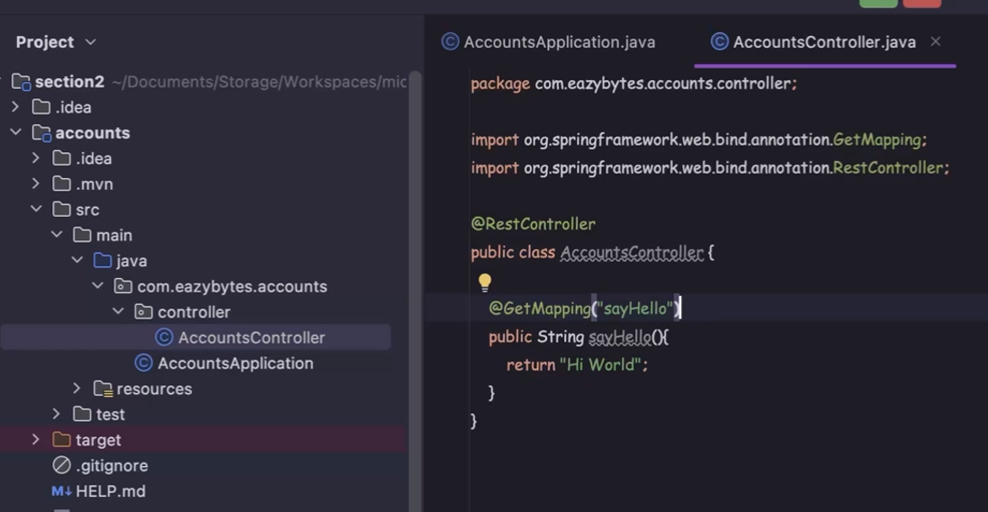

We need to specify data base related properties in application.prop file as below

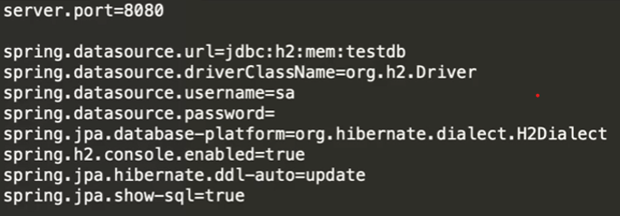

Now a days yml is being used to define properties which is based on indentation hence its very important to properly format the properties as below.

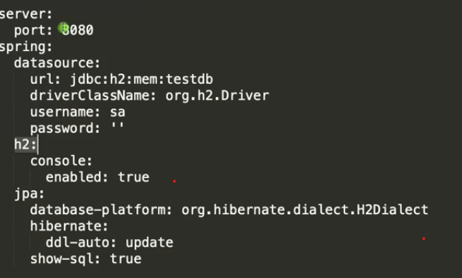

To create tables in H2 DB create schema.sql spring boot will excute from sql files 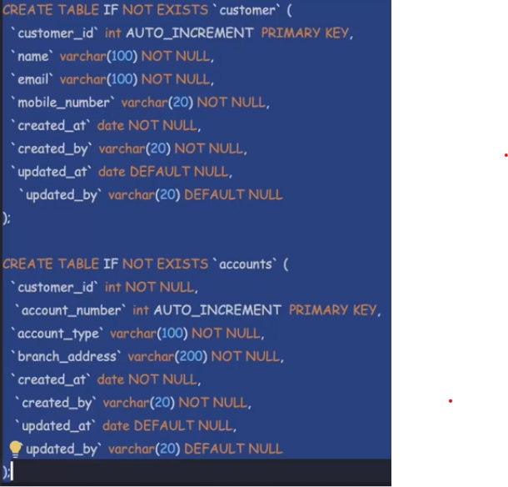

Lets start creating java classes that communicate with DB using hibernate. To do this will create entities classes

BaseEntity serves as superclass for customer and accounts entity as it contains common fields hence mapped with @MappedSuperclass annotation and other annotations to fields

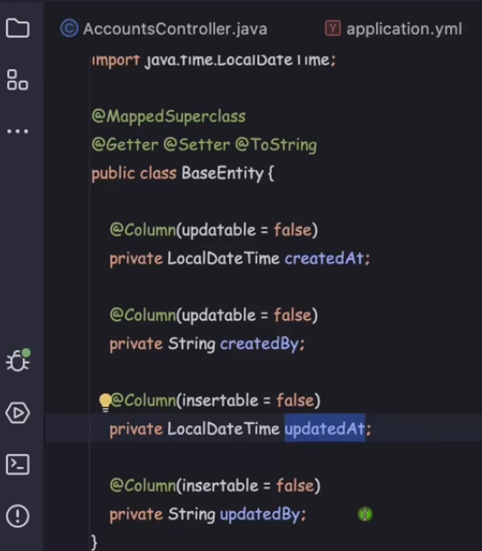

We don’t have to provide getters and supports as lombak will do for us

Now lets create customer and accounts entity

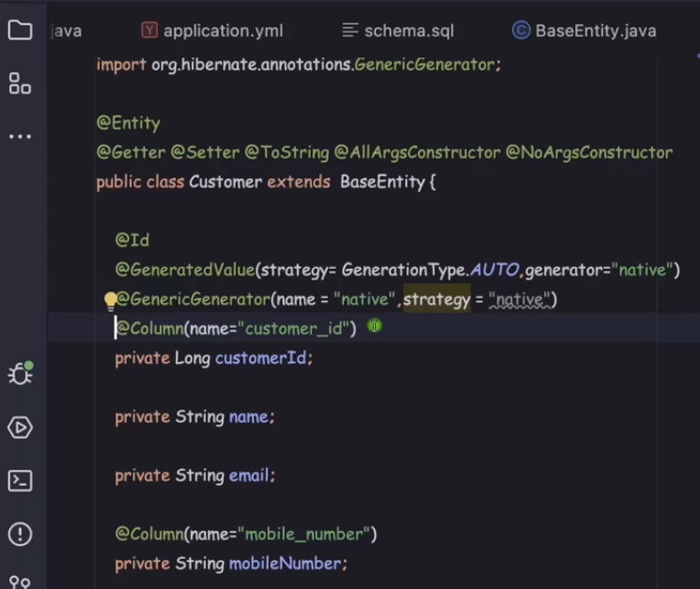

@Column is optional if it matches with db column name but its good practice to add @Column

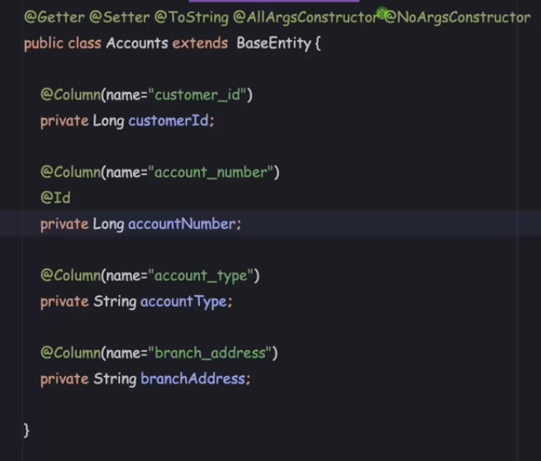

Lets create repositories Accounts and Customer repositories

But before that will create DTO which is required to send response to Client.

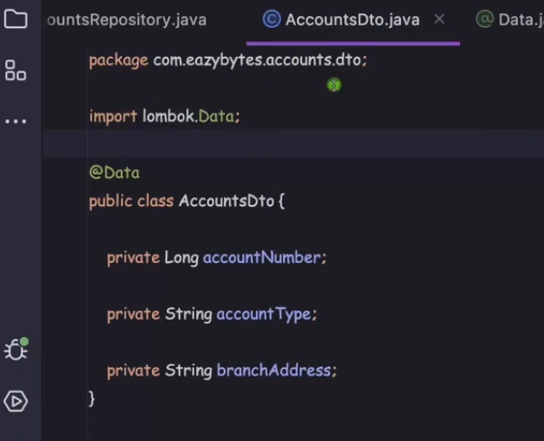

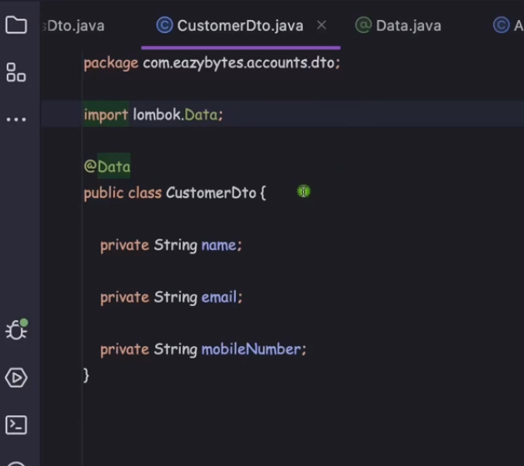

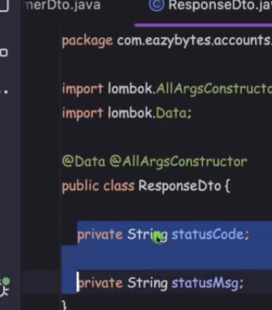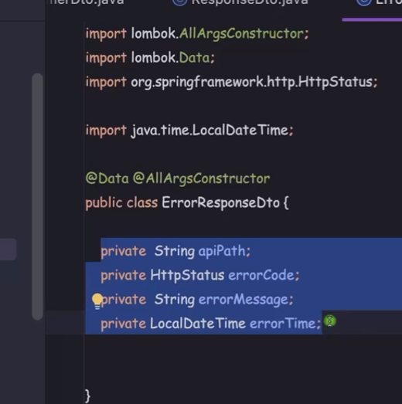

Now lets create restcontrollers

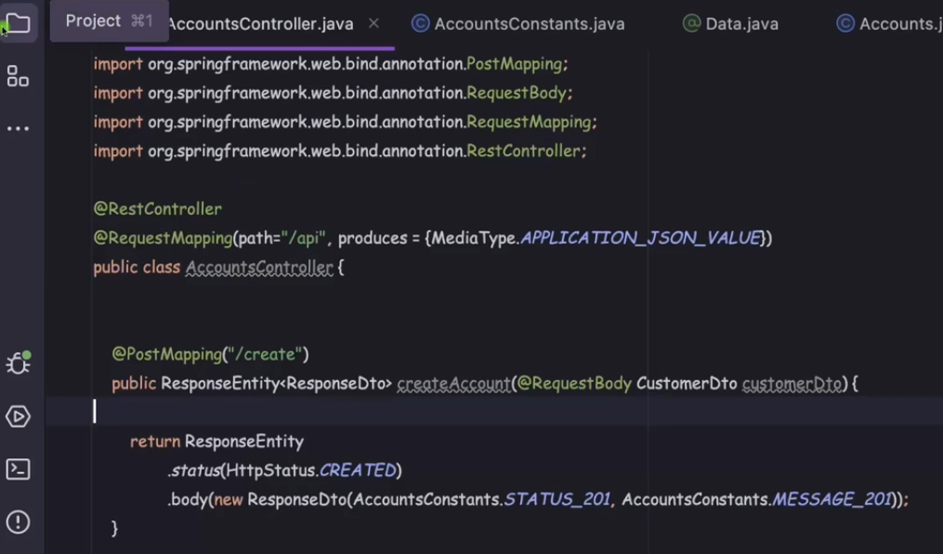

Here accounts constants is constant file pls chk on github

Lets create service class

Accounts mapper and customer mapper is used to convert from DTO to Entity

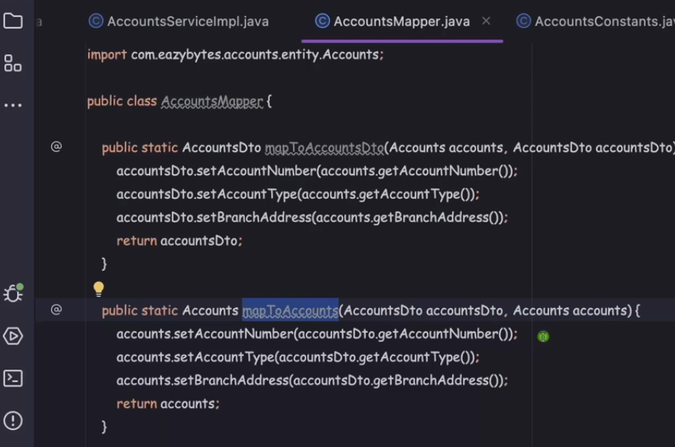

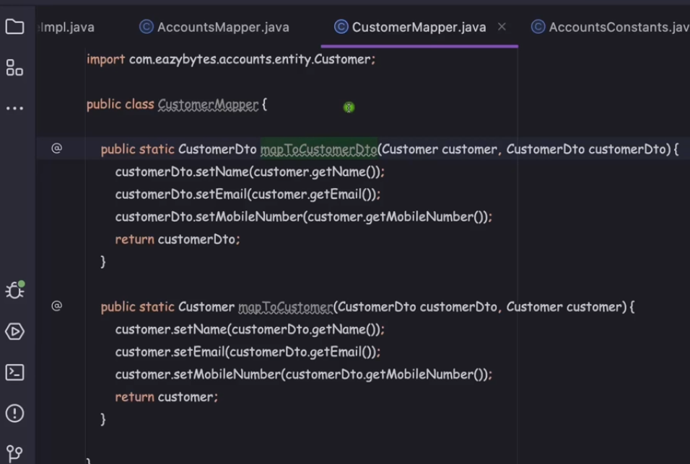

Accounts repository

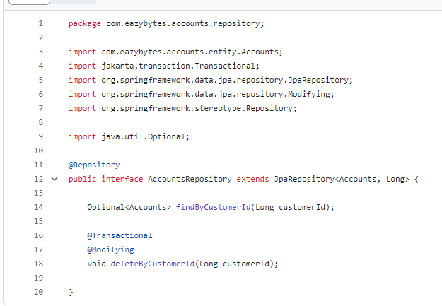

Customer repository

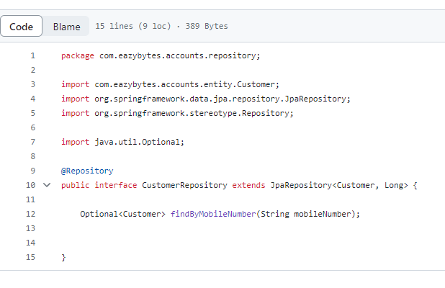In service create a method that creates and saves customer and accounts details

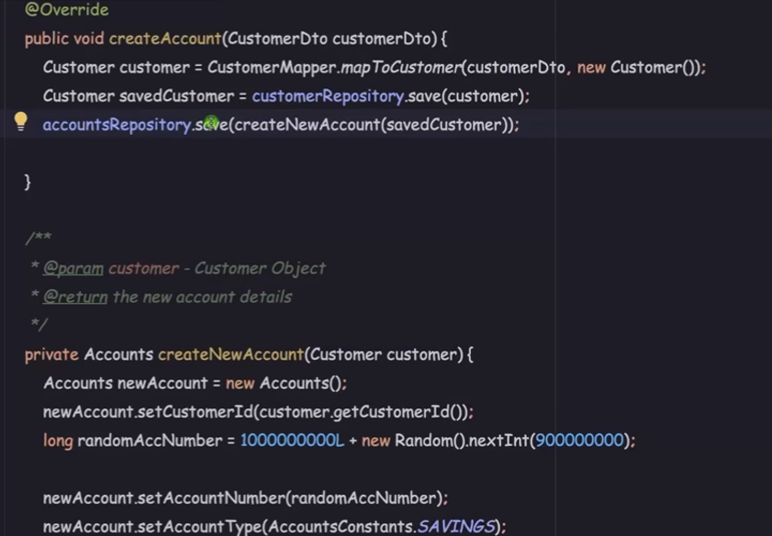

Lets create exception handler class

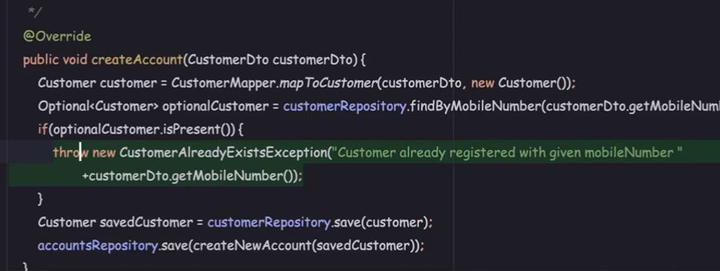

Below is the custom exception

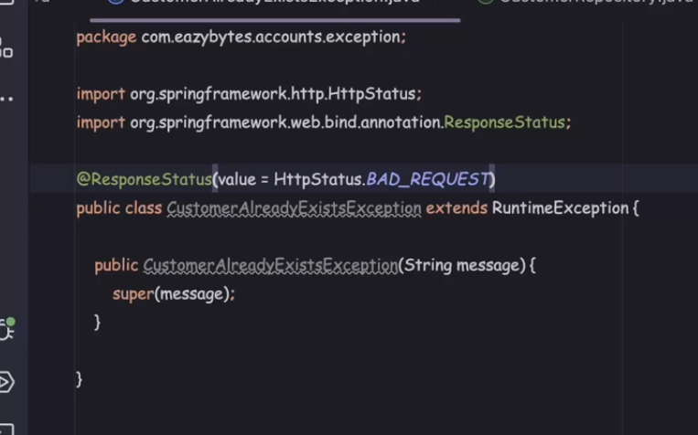

We can handle global exceptions by creating class with annotation @ControllerAdvice

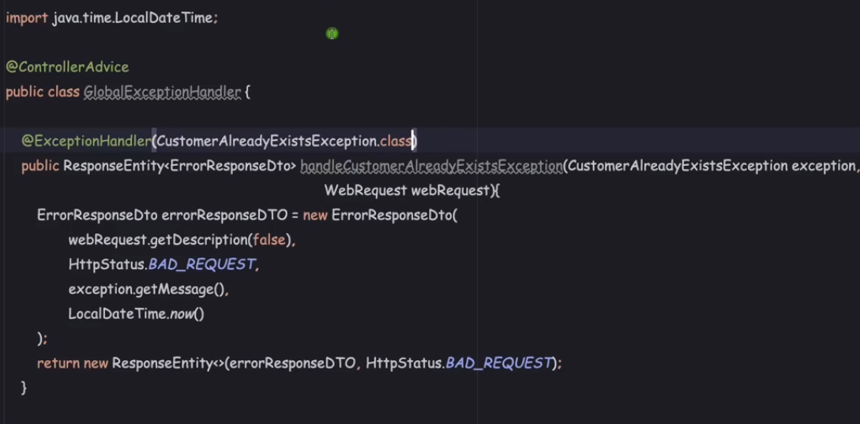

Now will call the create API using post

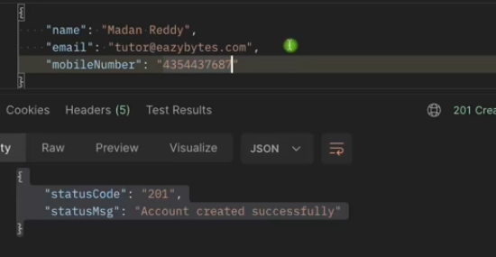

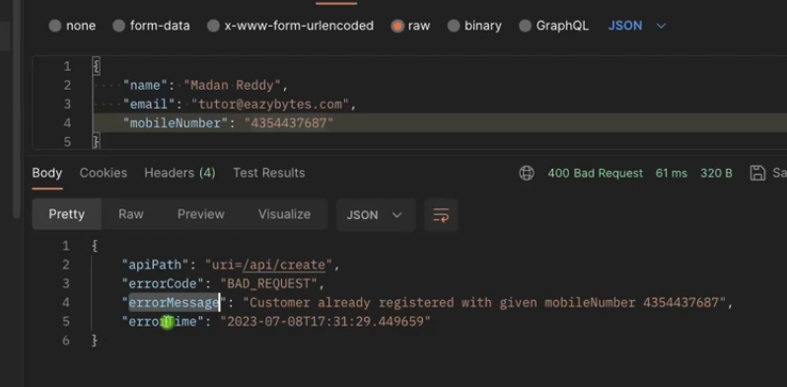

This above code is only for reference pls chk github

Now for validating inputs values we can do it by annotations easily for that we need add dependency statrter-validation

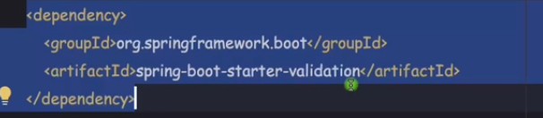

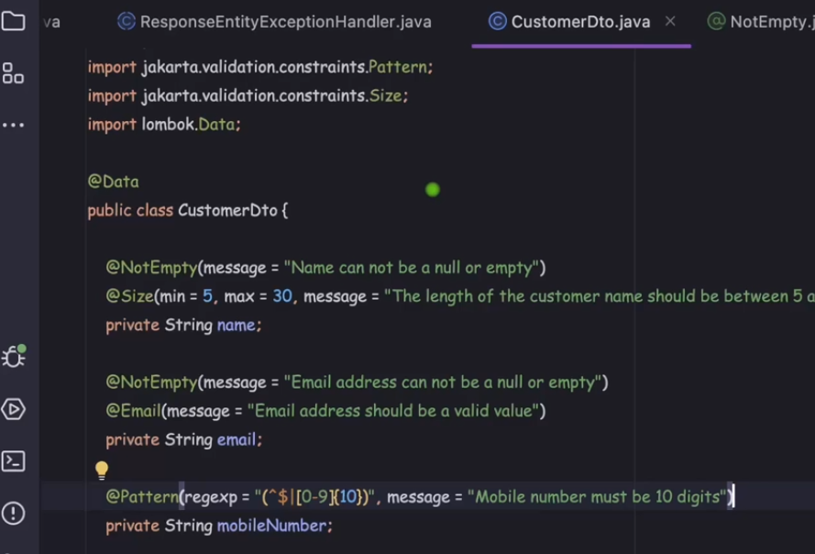

Similarly you can add other annotations for email validation and many are available

